HALF ADDER

EXP.NO: 21

AIM:

To design and implement the two bit half adder using
Logisim simulator.

PROCEDURE:

1) Pick and place the necessary gates.

2) Insert 2
inputs into the canvas.

3) Connect
the inputs to the XOR gate and AND gate.

4) Insert
2 outputs into the canvas.

5)
Make the connections using the
connecting wires.

6) Verify the truth table.

TRUTH TABLE:

A

B

S

C

0

0

0

0

0

1

1

0

1

0

1

0

1

1

0

1

S = A XOR B C = A AND B

OUTPUT

RESULT:
Thus
2-bit half adder has been designed and implemented successfully using logisim
simulator.
Class comments

Add class comment…
HALF ADDER

EXP.NO: 21

AIM:

To design and implement the two bit half adder using
Logisim simulator.

PROCEDURE:

1) Pick and place the necessary gates.

2) Insert 2
inputs into the canvas.

3) Connect
the inputs to the XOR gate and AND gate.

4) Insert
2 outputs into the canvas.

5)
Make the connections using the
connecting wires.

6) Verify the truth table.

TRUTH TABLE:

A

B

S

C

0

0

0

0

0

1

1

0

1

0

1

0

1

1

0

1

S = A XOR B C = A AND B

OUTPUT

RESULT:
Thus
2-bit half adder has been designed and implemented successfully using logisim
simulator.
Class comments
Add class comment…
HALF ADDER

EXP.NO: 21

AIM:

To design and implement the two bit half adder using
Logisim simulator.

PROCEDURE:

1) Pick and place the necessary gates.

2) Insert 2
inputs into the canvas.

3) Connect
the inputs to the XOR gate and AND gate.

4) Insert
2 outputs into the canvas.

5)
Make the connections using the
connecting wires.

6) Verify the truth table.

TRUTH TABLE:

A

B

S

C

0

0

0

0

0

1

1

0

1

0

1

0

1

1

0

1

S = A XOR B C = A AND B

OUTPUT

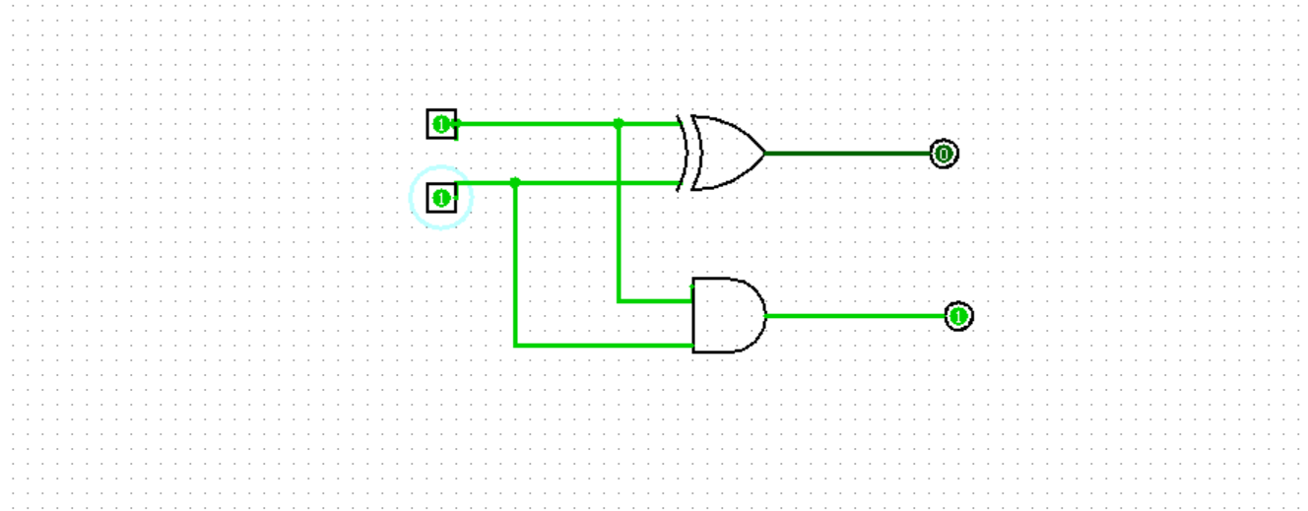

RESULT:
Thus
2-bit half adder has been designed and implemented successfully using logisim
simulator.

